Evolution of a Recurrent Neural Net that is Responsible for Steering an Agent in 2D Grid World

Chavdar Levkov, NBU 2009

CREATE a network with stronger feedback connections!

This article is presenting the evolution of a virtual agent that is moving in a 2D virtual world. The thing that is evolving is the ability of the agent to eat as much food as possible for a given amount of time. The agent moves are governed by a neural network (it’s brain). Evolution is achieved by creating many such virtual worlds each having an agent in it that lives for certain amount of time. At the beginning each agent has random weights in its neural network and so its behavior will look undirected. After the first generation of agents has lived their lives the agents that have eaten most food are selected for reproduction – their neural networks are used for creating new ones. The new agent networks are created by copying old ones but with some random changes in few of the weights (mutations). This way generation by generation the fittest neural networks are selected and reproduced with minor errors so that it is expected after certain amount of time positive changes will occur in the behavior of the agents towards eating food very efficiently.

The virtual grid world

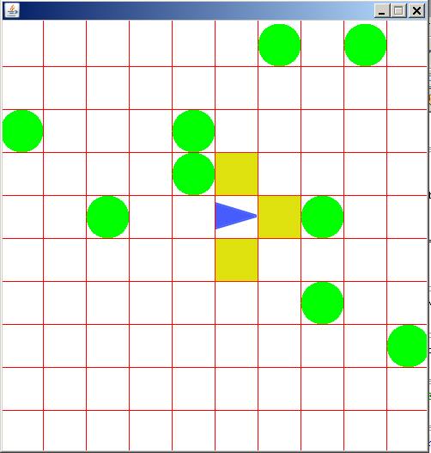
Fig.1

In Fig.1 the virtual world is presented. There are two sprites in this world: The agent (blue triangle) and the food (green circles). Each object can be located in on of the many squares.
The virtual world has the following rules:
- The agent is moving thru the grid world. Possible actions are: Turn left, turn right and move forward.
- If the agent steps on a food element the food disappears and the agent is considered to have eaten the food. In the exact same time a new food element sprouts at a random location on the grid world.
- The agent has the ability to sense food when the food is directly in front in left or in right of the agent. For example in Fig.1 the squares colored in yellow are the squares where the agent can tell if there’s food or not. In this case no food is present.
- Each time a food is eaten by the agent it is stored so that the ability of the agent to eat food can be determined (it’s fitness).
- If the agent moves out of the boundaries of the grid world it will come from the opposite site.

The grid world simulation is written in JAVA. A single class is responsible for managing every thing: food locations, adding new food, managing the position of the agent, getting the current input from the agent’s sensors and more.

The Brain of the Agent - Recurrent Neural Network

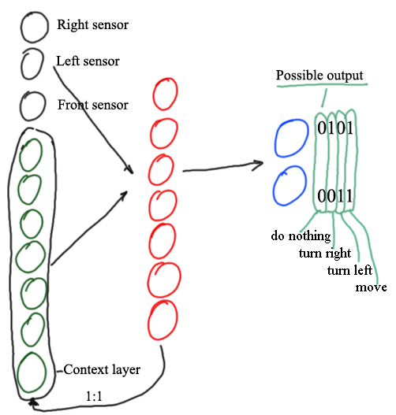
Fig.2

The thing responsible for steering the agent within the 2D grid world is a neural net (Elman Network) presented in Fig.2. All the units in the network are binary threshold units with threshold of 0. The network has 3 input elements (in black) that represent the sensors of the agent. Input can be either 1 or 0. If certain input element has a value of 1 this means food is located on the respective side. If the value is 0 no food is presented. The hidden layer (in red) has 7 units. Each epoch the activity of the hidden layer is copied in the context layer (in green) so that the activity of the first neuron form the hidden layer is copied into the first neuron of the context layer and so on. The output of the network (in blue) is responsible for the actions of the agent. There are four possible actions: Do nothing, turn right, turn left and move. These actions are coded by the output the following way (see Fig.2):
Do nothing - 0, 0 – both neurons have output of zero
Turn left - 0, 1 – only the first neuron is active
Turn right - 1, 0 – only the second neuron is active
Move - 1, 1 – both neurons have output of 1

Typical Simulations

Each simulation is an interaction between a virtual grid world (realized in java class) and a neural network (again in java class). The sequence of the simulation is the following:
- Multiple GridWorlds are created (e.g. 100), for each a desired number of food elements are added at random positions, and then the agent is added at a random position.
- Multiple neural networks are created (e.g. 100) each assigned to an Agent in a GridWorld. At the beginning each of the networks has random weights.
- Each neural is assigned to an Agent inside a GridWorld. Using the sensory input from the GridWorld each network calculates some output – action.
- This action is feed into the GridWorld which is updated accordingly. For example if the network decides to move the GridWorld should update the position of the agent. If the agent eats a food element the GridWorld should count it, and also add new food element at random position.
- After some amount of actions (epochs) the Agent life will end. At this moment new networks are created by using the old ones that have eaten most food. For example if there are 100 networks in one generation, the next generation could be created by reproducing the best 5 networks - from each network 20 new are created by copying the weight matrices but with some minor random errors (mutations).
- The new generation will live for the same amount of time as the old and then a new one will be created. This process will continue for several hundred or thousand generations. At the end it is expected that the weights of the networks will be changes so that networks will have “intelligent” behavior when looking for food in the 2D world.

Simulations
From now different simulations that were run will be presented.

- Simulations with 1 Food element – Several simulations, when 1 food element is available into the grid world, were done. For each simulation all the parameters were the same except the duration of the generations (how many epochs are done before the new generation is created) and the number of generations that were run.

Simulation 1
GridWorld  settings | Size | 10x10 cells
GridWorld  settings | Number of food elements | 1
RNN  settings | Input elements | 3
RNN  settings | Hidden units | 7
RNN  settings | Output units | 2
Simulation  settings | Generations | 100
Simulation  settings | Epochs in one generation | 500
Simulation  settings | Number of simulations | 6
RESULTS | Best fitness achieved by  single individual
RESULTS | Best fitness achieved by  whole generation

*In the next simulations for shortness some of the parameters are omitted because they are the same as in simulation 1.
Simulation 2
 | Epochs in one generation | 1000
 | Number of simulations | 6
RESULTS | Best fitness achieved by  single individual
RESULTS | Best fitness achieved by  whole generation

Simulation 3
 | Epochs in one generation | 5000
 | Number of simulations | 5
RESULTS | Best fitness achieved by  single individual
RESULTS | Best fitness achieved by  whole generation

Simulation 4
 | Epochs | 25000
 | Number of simulations | 1
RESULTS | Best fitness achieved by  single individual
RESULTS | Best fitness achieved by  whole generation

Simulation 5
Simulation  settings | Generations | 200
Simulation  settings | Epochs | 50000
Simulation  settings | Number of simulations | 1
RESULTS | Best fitness achieved by  single individual
RESULTS | Best fitness achieved by  whole generation

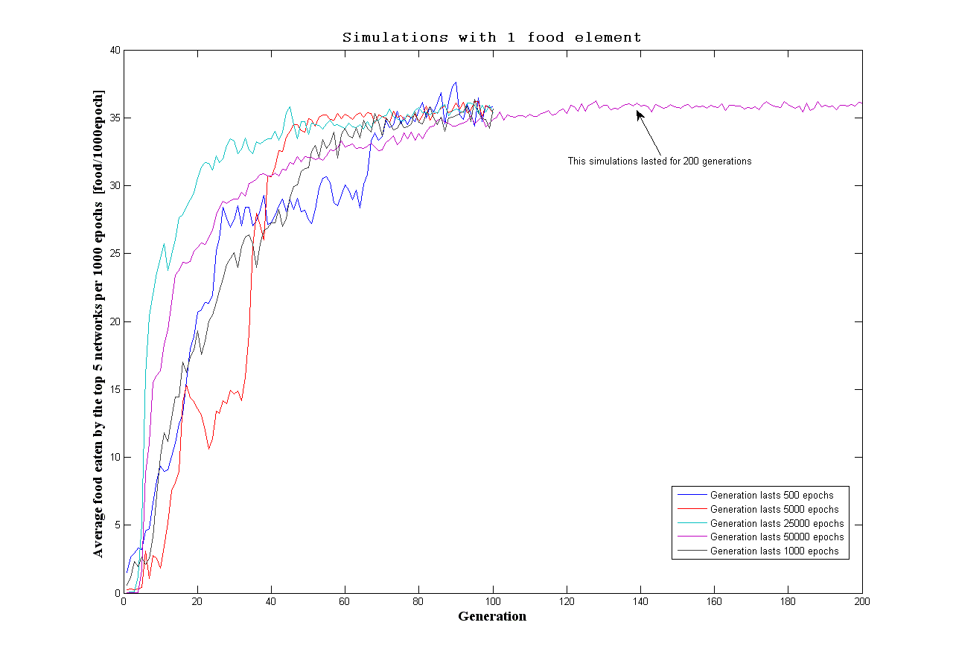Fig.3
Fig.3 shows the results from the 5 simulations. Simulations 1 and 2 were run 6 times each and the averaged results are presented. Simulation 3 was run 5 times and the presented results are also averaged. Simulations 4 and 5 were run only once.

All the simulation give the same result, that the best networks at the end of the simulations eat the same amount of food – around 35 food elements per 1000 actions.

